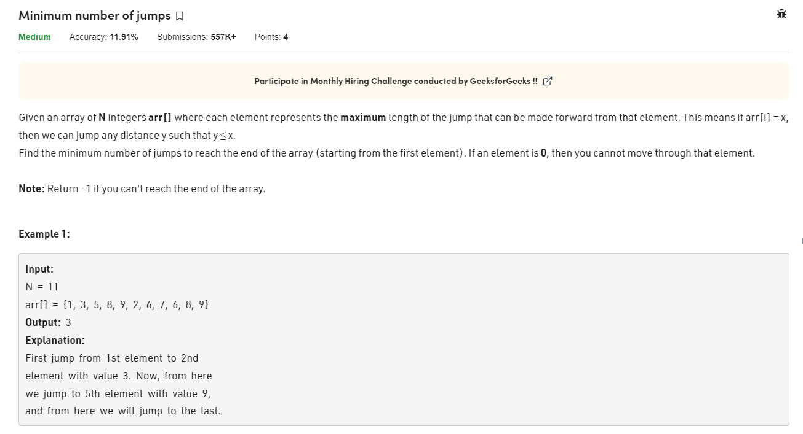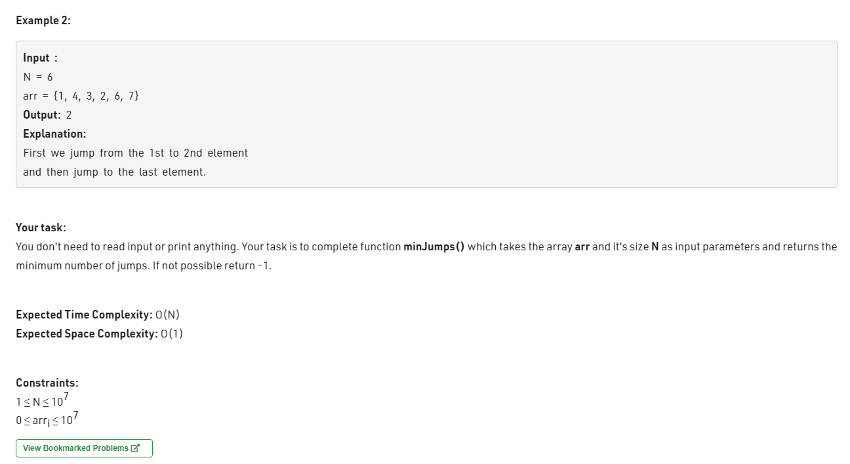class Solution{

static int minJumps(int[] arr){

// your code here

int jump=0, farthest=0,current=0;

for(int i=0;i<arr.length-1;i++){

if(i==current && arr[current] ==0 && current==farthest){

return -1;

}

farthest = Math.max(farthest, arr[i]+i);

if(i==current){

current = farthest;

jump++;

}

}

return jump;

}

}